May 2021 Media Release
Ready, Box Set Go

Physical Theatre company are centring a creative approach to learning with new ‘drama lesson in a box.’

With students and teachers alike feeling the pressure as lockdown eases, arts education has a vital role to play. To address this, award-winning charity Highly Sprung Performance have launched Ready Box-Set Go, a dynamic, classroom-ready learning resource for Key Stages 1 to 5 that explores engaging, relevant themes. It will help develop essential soft skills that may be missed by the catch-up curriculum: rebuilding confidence, fostering strong peer relationships and equipping pupils with the emotional tools they need post-lockdown. Building on 20+ years working with children and young people in educational settings, the programme packages up the ‘Highly Sprung experience’ in a way that is accessible in current conditions, empowering pupils when they most need it and taking the strain off teachers.

Ready Box-Set Go will provide teachers with boxes packed full of physical and digital resources to deliver in the classroom, along with structured lesson plans and CPD. Students aged 5 to 18 will find their unique creativity through a range of fun creative challenges, movement workshops, artist-led digital activities and access to online performances.

KS1: New Book for the Emperor looks at creative writing as children fill the Emperor’s book with imaginative stories.
KS2: Arty’s Broken Heart investigates heart health. Through a creative combination of movement, science and art, children develop positive attitudes towards physical activity and improving health outcomes.
KS2/3: Hidden in Plain Sight tells the incredible story of William and Ellen Craft’s escape from slavery, examining racism in both the past and present.
KS3/4/5: Fallout and Urban Astronaut inspire important conservations on social action, mental health and the climate change crisis. They will also build valuable skills for GCSE and A-Level devising projects through giving insight into Highly Sprung’s process.

“I've never seen or used such an in depth set of video resources all linked to a live performance before - these are incredible, and by far, one of the best digital resources I've ever used. I can't wait for the physical box set to arrive.”
-Jonny Howard, Cliff Park Academy & National Lead for Performing Arts at the Ormiston Academy Trust

“Ready Box Set Go is Highly Sprung’s response to the challenges teachers are facing. It provides a unique set of tools that empowers teaching staff to use the Highly Sprung methodology in easy-to-follow activities. Each session is carefully crafted to provide enjoyment and inspiration for students, developing their creativity, collaboration and critical thinking skills. We have invested time to support students’ mental wellbeing, providing the opportunity to immerse themselves in projects that feel purposeful and supporting their development as individual learners.”
- Sarah Worth, Executive Director

For more info on Ready Box Set Go visit https://www.highlysprungperformance.co.uk/learning/schools/ or email team@highlysprungperformance.co.uk.
For more information please contact:
Sarah Worth, Executive Director, Highly Sprung
sarah@highlysprungperformance.co.uk, 07810 263355

About Highly Sprung

Highly Sprung Performance is the UK’s leading physical theatre company creating work with and for children and young people. As a charitable organisation, we use our signature approach to empower young people, helping them find their unique performance style and discover their voice.

In 2020 we were awarded the Pearson’s Teaching Gold Award for our collaboration in commemorative arts engagement project Echo Eternal, working with the Core Education Trust and schools across the West Midlands. We create award-winning outdoor and indoor performances that tell stories through movement, gesture and dance. Stories inspired by humanity, science and the complex world around us.

For the last 20 years, Highly Sprung has worked with primary and secondary schools across the UK and internationally and runs weekly performance workshops in Coventry for children and young people aged 5-18.

Highly Sprung are best known for Urban Astronaut, which has toured over 40 venues and festivals internationally, as well as Home, an aerial spectacle celebrating Coventry’s history, and additionally for the Physical Fellowship, the UK’s only festival exclusively for young people and emerging artists.

http://www.highlysprungperformance.co.uk
@HighlySprung

Social Media
Twitter (@highlysprung)
Instagram (@highlysprung)
Facebook (Highly Sprung Performance Company)
YouTube (Highly Sprung Performance)

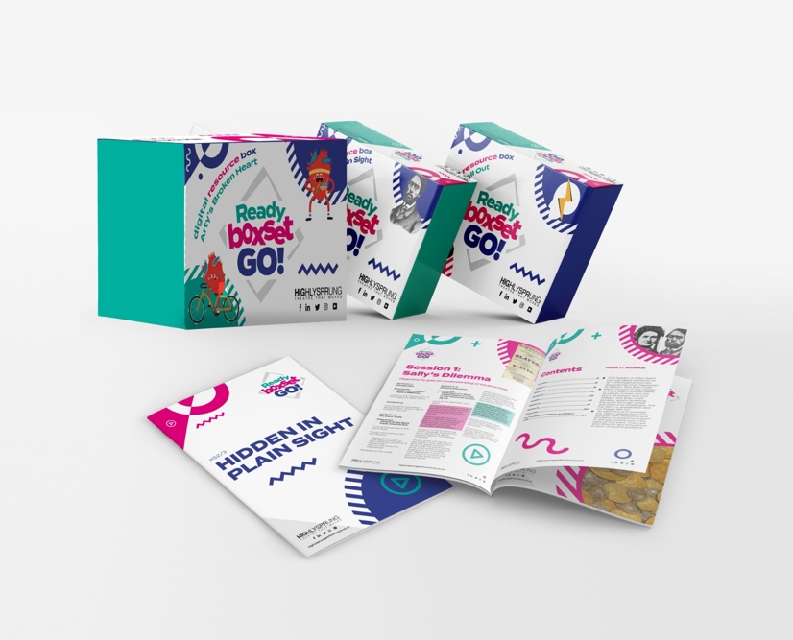
Images: Urban Astronaut by Highly Sprung Performance & Ready Box Set Go for Key Stages 1-5

